Technical Document: PlacementTech QGIS Plugin

1. Overview: PlacementTech is a QGIS plugin designed for creating and manipulating line features. It offers multiple digitization modes and tools for creating offsets and fixed-length lines.
2. Main Features: a. From Point Mode b. Standard Mode c. Draw Offset d. Fixed Length Line Creation
3. User Interface: The plugin interface consists of:

* A dropdown menu to select digitization mode
* A "Start" button to initiate the selected mode
* A "Draw Offset" button
* An input field for fixed length
* An "Enter" button to confirm fixed length

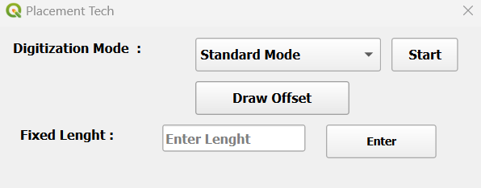

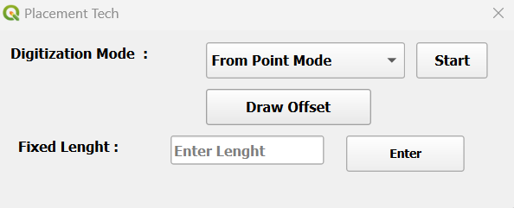

1. Usage Instructions:

4.1 From Point Mode:

1. Select "From Point Mode" from the dropdown menu.
2. Select a point feature from the 'point_layer'.
3. Click "Start".
4. Left-click on the map to add vertices to your line.
5. Right-click to finish the line creation.

4.2 Standard Mode:

1. Select "Standard Mode" from the dropdown menu.
2. Click "Start".
3. Left-click to start the line and add vertices.
4. Right-click to finish the line creation.

4.3 Draw Offset:

1. Select a line feature from the active layer.
2. Click "Draw Offset".
3. In the popup dialog:
   * Enter the offset distance in meters. + is right side and – is negative side
   * Check "Offset on both sides" if desired.click on ☑ checkbox
4. Click OK to create the offset line(s).

4.4 Fixed Length Line Creation:

1. Enter the desired line length in the "Enter Lenght" field.
2. Click "Enter".
3. Click on the map to set the starting point of the line.
4. Move the cursor to set the direction, and click again to create the fixed-length line.
5. Technical Notes:

* The plugin requires two layers: 'point_layer' and 'line_layer'.
* Ensure the correct CRS is set for accurate distance calculations.
* The plugin uses QgsRubberBand for temporary visualization during digitization.
* Offset distances are converted from millimeters to the layer's CRS units.

1. Error Handling:

* The plugin provides error messages for common issues such as:
  + Missing required layers
  + No features selected when required
  + Failure to start editing or commit changes

1. Limitations:

* The fixed length tool currently creates lines at a 0-degree angle (east direction).
* The plugin assumes the existence of specific layers ('point_layer' and 'line_layer').

This document provides a basic overview of the PlacementTech plugin's functionality. For more detailed information or troubleshooting, please refer to the source code or contact the plugin developer.